**Manual Sketches Digitizer**

User Manual





160557T

G.L.C.A.Sandeepa.

**Requirements**

1. Windows operating system.
2. “Tesseract OCR engine” for the user’s computer.

(The setup of Tesseract OCR engine is uploaded in configuration folder)

**Getting started**

1. Install the “Tesseract OCR engine”.

Open the setup of Tesseract OCR engine given in the “configuration files” directory.

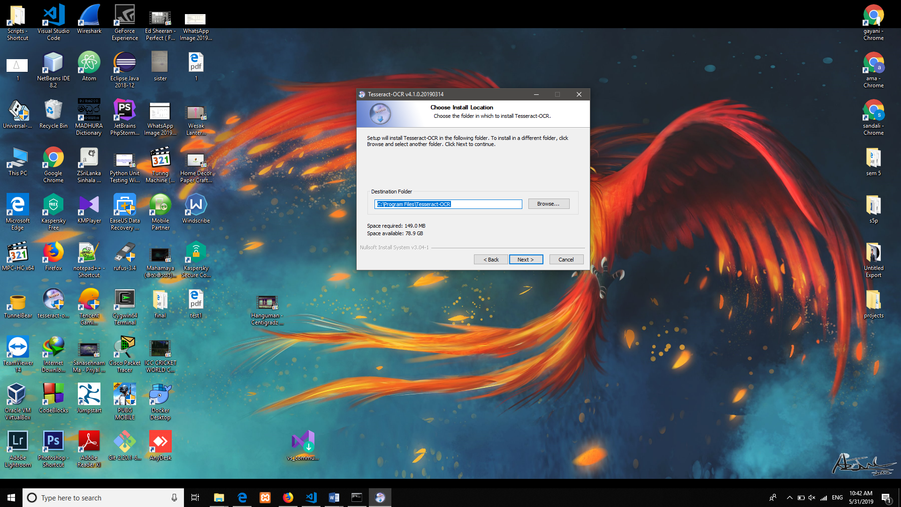

Install the Tesseract OCR in the above mentioned directory.

( “C:\Program Files\Tesseract-OCR”)

1. Open the software folder where the executable file exists.

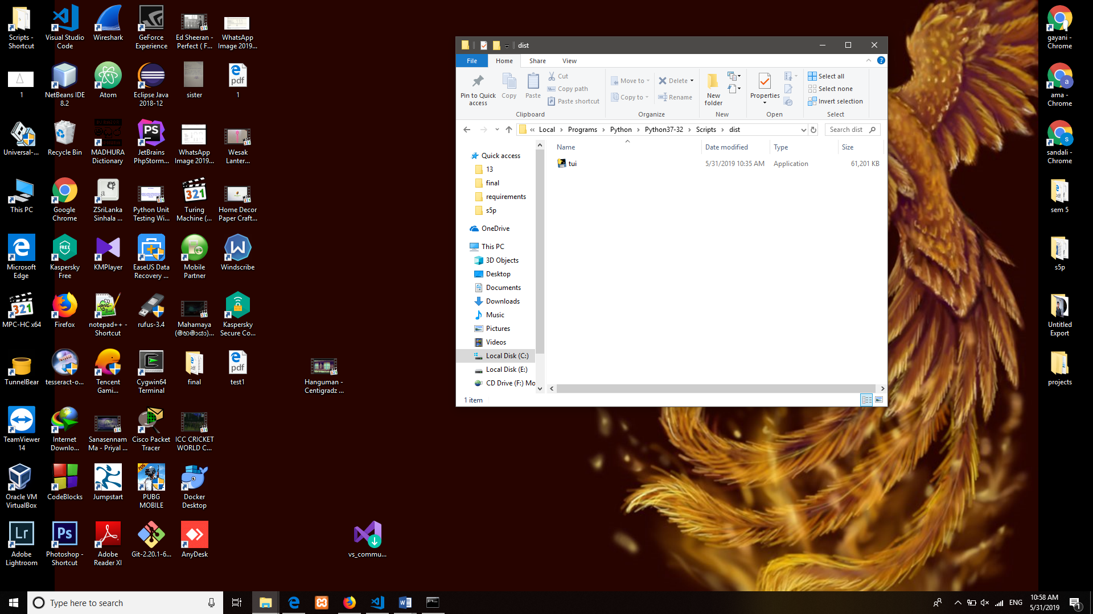

1. Open the “tui.exe” file. ( the executable file of the Manual Sketch digitizer)
2. 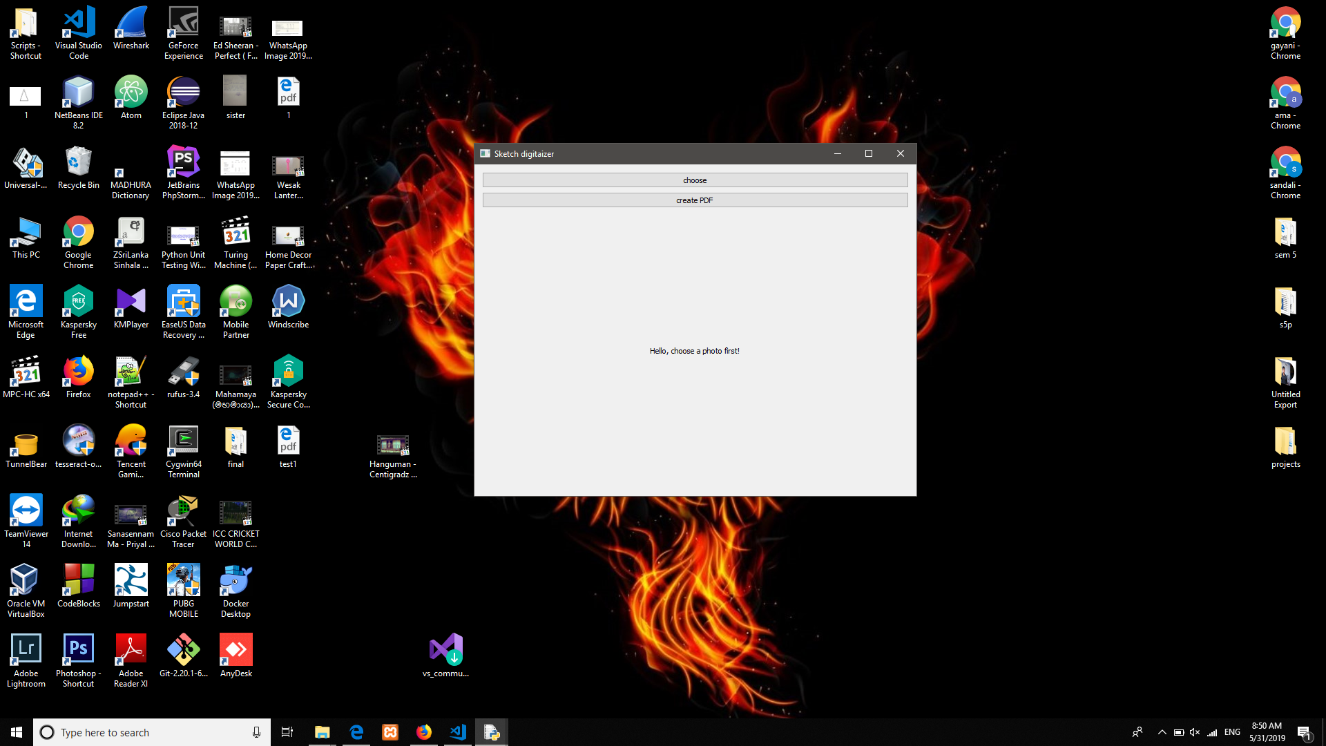The main interface is given below.
3. Choose the image wanted to digitalize by clicking “choose” button.

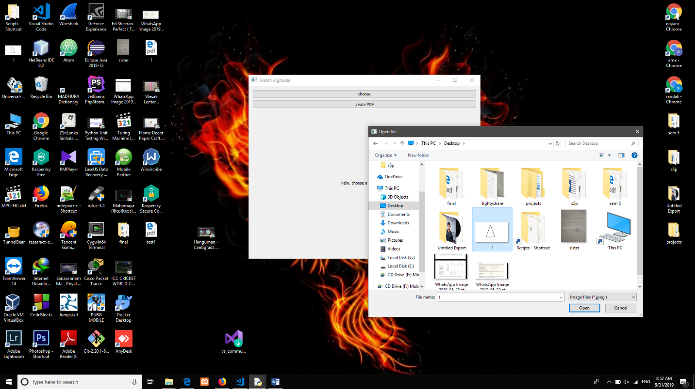

1. Then the interface shows the image you chosen.

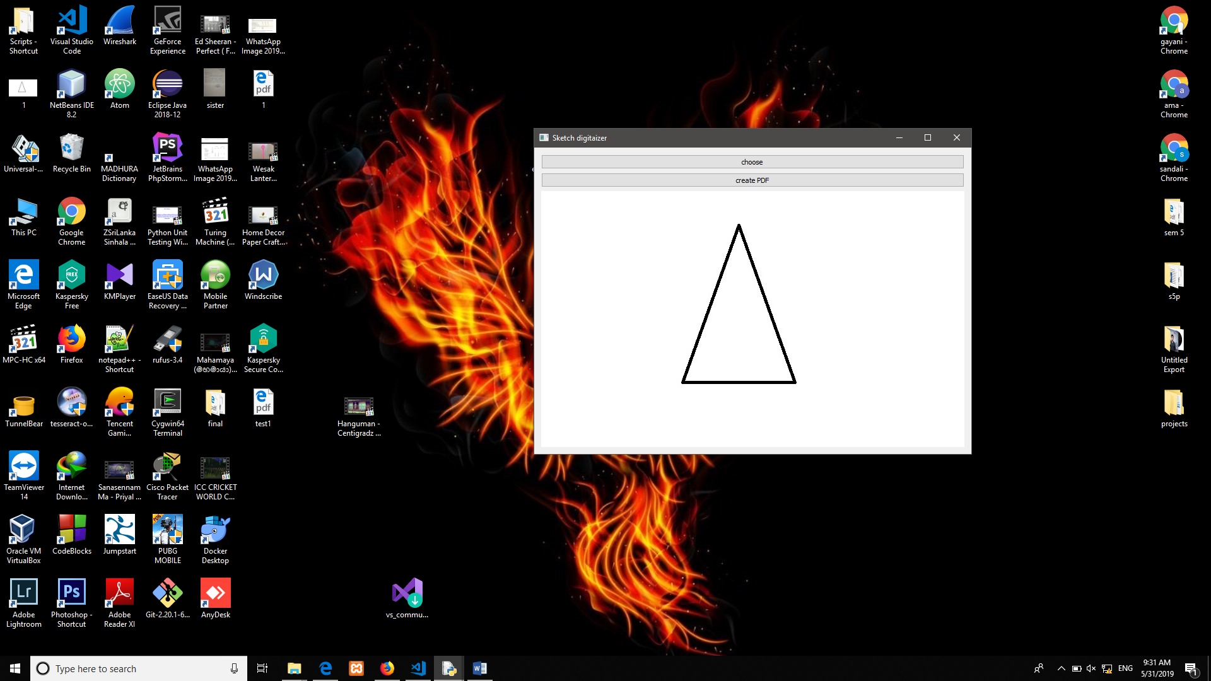

1. Then click “create PDF” button to generate the PDF output. Then it is wanted to select preferred directory to store the PDF document of the raw image input.

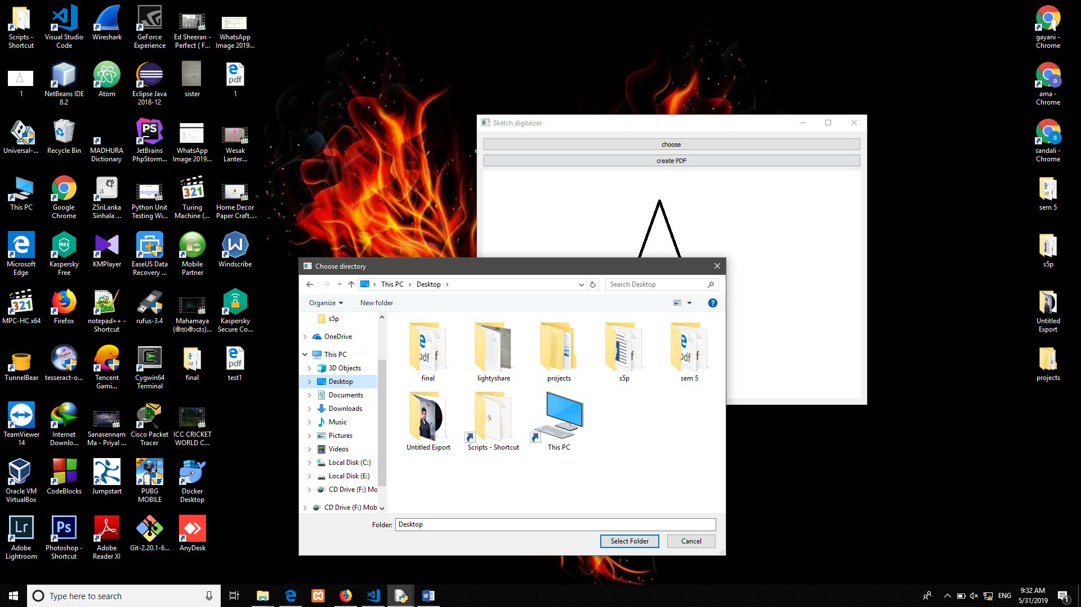

1. 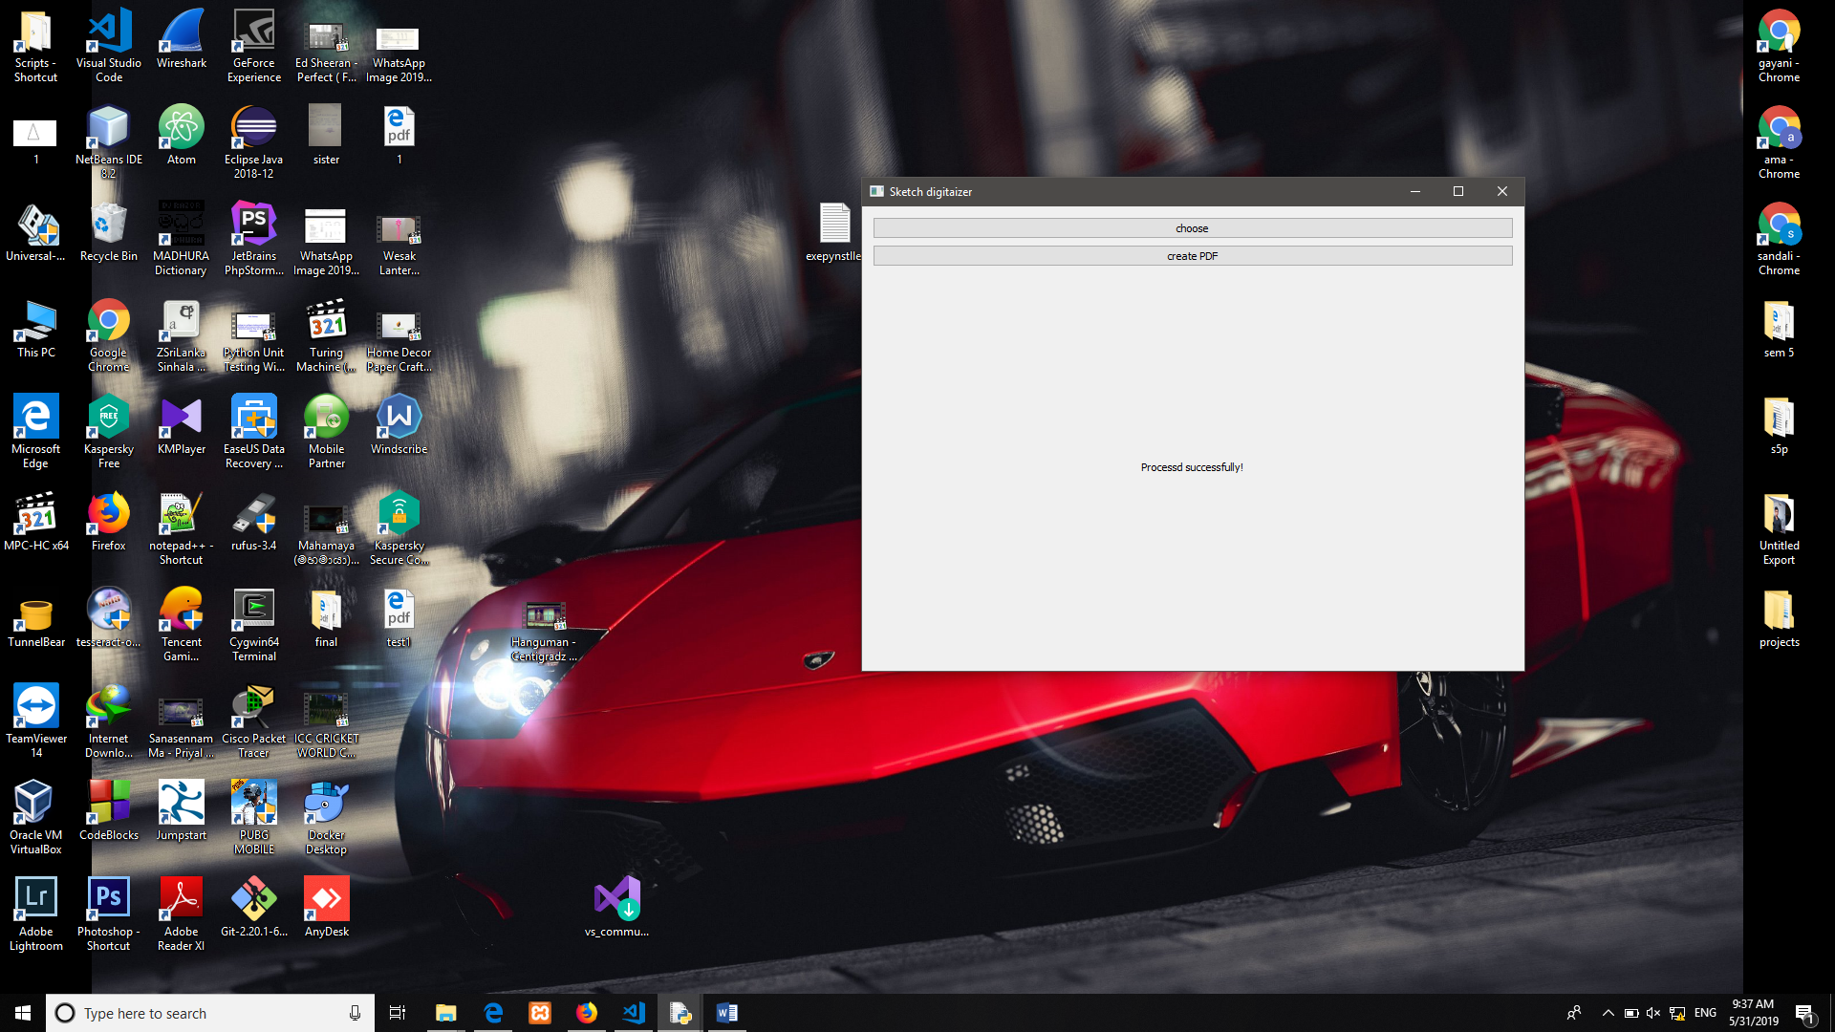Finally, if the PDF document is generated successfully then it is shown “Processed successfully” in the interface.